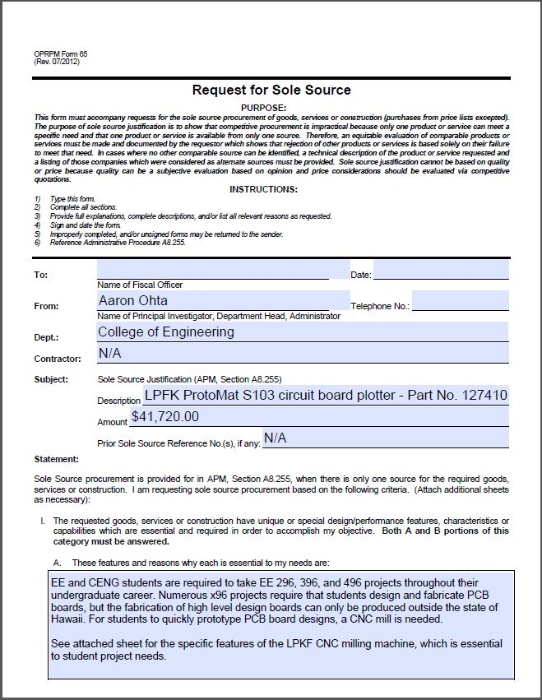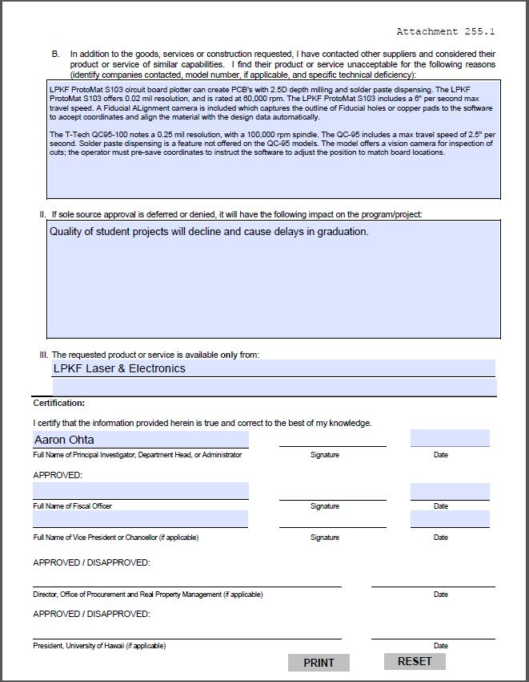

Comparison of LPKF ProtoMat S103 and T-Tech QC-J5 models

Below is a comparison of the LPKF ProtoMat S103 and the T-Tech QC-J5 with a 100,000 rpm spindle, I have highlighted the most notable advantages provided with the ProtoMat S103.

**LPKF CircuitPro Software:**

-       Included with purchase of the ProtoMat E33, S43, S63 or S103 systems.

-       Allows for up to 10 downloads to allow data prep away from the machine

-       Includes Wizards to guide operator through application

-       The software will provide step by step procedure for creating the design with use of additional LPKF products (silver plating, lamination press for multilayer, solder mask stage, solder paste dispensing, reflow oven, etc.)

-       Help categories also included within CircuitPro for operations of the machine

(details are also included in the attached Sample Sole Source Spec document)

**Travel Speed:**

-       The LPKF ProtoMat S103 includes a 6” per second (360” per min) max travel speed which saves time on projects and is faster than non-LPKF systems; the QC-J5 notes only a 2.5” per second or 150”/min max travel.

-       The LPKF software algorithm for tool paths is also optimized to reduce movements of the head, keeping the tool in contact with the material whenever possible

**Resolution:**

-       LPKF ProtoMat S103 offers 0.02 mil resolution or 0.5µm. The QC-J5 notes only (0.00025”) or 0.25 mil resolution

**Z-Resolution:**

-       LPKF ProtoMat S103 offers a stepper motor control on the z-drive and 0.2 µm resolution; this is not provided for the QC-J5

**Repetition Accuracy:**

-       LPKF ProtoMat S103 offers 1µm control of the stepper motor z-drive; this figure is not provided for the QC-J5

**Tool Change:**

-       LPKF ProtoMat S103 includes a 15 position tool exchange with stainless steel prongs for quick alignment of the entire tool bar. The included Fiducial Camera allows for registration of all 15 positions with one fiducial calibration. T-Tech also offers auto-tool change but with a collet design, the tool may need manually loaded within the head unit and then instructed to be places in the tool change positions. The LPKF prong systems allows for rapid manually insertion of the tools for rapid tool loading.

**Auto Tool Depth Sensing:**

-       With the LPKF ProtoMat S103, tools are touched to a point on the graduated ramp for auto-tool depth setting which corresponds with the copper weight. The tool can be set between 0.0mm and 1.8mm automatically based on the desired depth provided in the software by the operator. A second option allows for depth milling without this ramp; the tool can be touched to the surface of the material and then instructed to cut to a spec ific depth for deeper pocket milling or cutting.

-       The tool depth setting is different on the T-Tech QC-J5 models as a depth ramp is not provided so a contact foot may be used for cut depth control.

**Solder Paste Dispensing:**

-       With the LPKF ProtoMat S103, solder paste can be dispensed based on the design data with as small as 0.4mm pads. Compressed air would be needed to operate the dispensing feature; this feature is not offered on the QC-J5 models.

**Vacuum Table:**

-       With the LPKF ProtoMat S103, a replaceable porous but rigid insert with even distribution of the vacuum is applied to full 9” x 12” work surface. This allows the air to pull material flat and prevent shifting but also allows for the drill bits and router tools to enter the backing. Replacement inserts are available but many projects can be completed before flipping the insert or swapping it out.

-       The vacuum table on the QC-J5 includes holes in the aluminum surface and a backing material with holes to allow suction on the material. This may cause suction on soft PCB materials at a concentrate point and effect the tool cut depth negatively. The QC-J5 allows for 4 separate zones to be used but this LPKF Vacuum Table can be covered to focus suction on smaller sections of materials.

**Fiducial Camera:**

-       With the LPKF ProtoMat S103, a true Fiducial Alignment camera is included which relays the visual location of the camera which captures the outline of Fiducial holes or copper pads to the software to accept coordinates and align the material with the design data automatically. This can also be used for visual inspection as the viewing window allows measuring of spacing/traces or drill hole sizes.

-       The QC-J5 may only offer a vision camera for inspection of the cuts; manual fiducial recognition may be possible but may require the operator to “save” coordinates to instruct the software to adjust the position to match the board locations.

LPKF originated PCB milling over 36 years ago and detailed above, our German engineered machines include a number of features which save time and money during R&D or prototype applications. These features allow for higher precision during the milling process (high quality spindle motors, faster travel speeds, fiducial alignment camera, auto tool change and auto tool depth setting (S63 and S103), etc.) and the new software is developed by LPKF in order to control the features and precision movements.

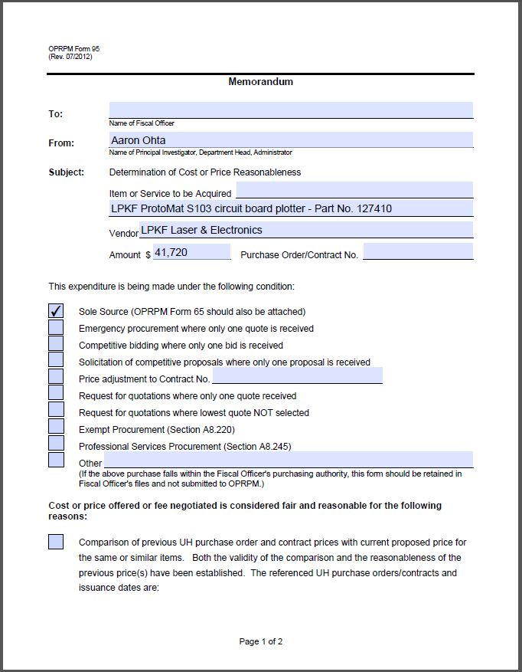

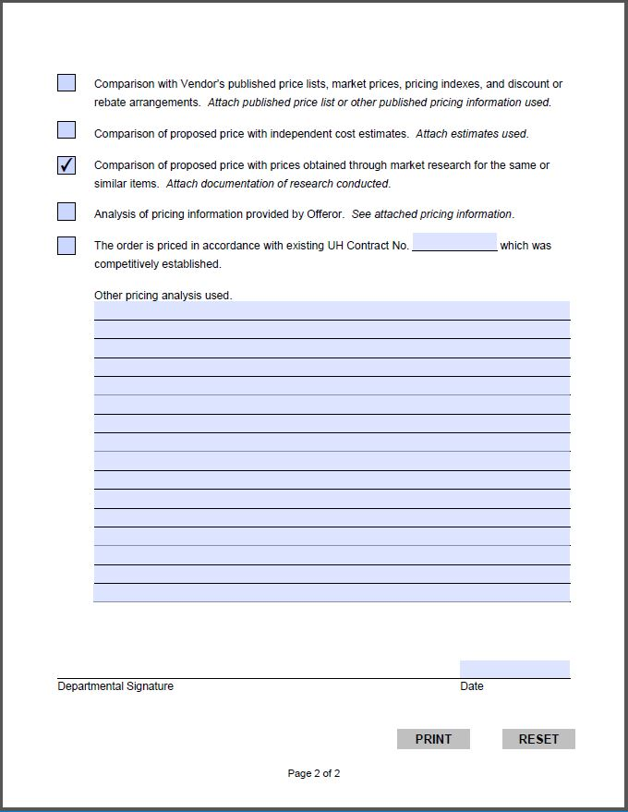

# Rapid PCB Milling Machine – Short Form

## PCB milling machines

### The PCB milling machine shall be the ProtoMat S43/S63/S103 as manufactured by LPKF Laser and Electronics, Inc., or equivalent.

#### The PCB milling machine shall be designed for use in a laboratory environment and include an acoustic cabinet featuring an integrated safety switch.

##### The PCB milling machine shall be able to recover from the accidental tripping of the safety switch without restarting the project.

#### The PCB milling machine shall be capable of being set up on a general lab table

#### The PCB milling machine shall utilize microprocessor based control of X, Y, and Z axis of the milling head.

#### The PCB milling machineshall be controlled by USB connection to a user supplied computer.

#### The PCB milling machine shall have integrated control electronics, located beneath the working table.

#### The PCB milling machine shall have 1.4” of Z axis travel, (S63/S103 – without the vacuum table installed); 0.9” with the vacuum table installed (S63/S103), 1.0” of Z axis travel (S43), controlled by stepper motor.

#### The PCB milling machine shall have software control of the Z axis for precise depth engraving, pocket milling, sign engraving and cutting of thick materials with multiple passes.

#### The PCB milling machineshall have a maximum working area of 9” x 12”.

#### The PCB milling machine shall have a movement resolution of 0.02 mils.

#### The PCB milling machine shall have a repetition accuracy of 0.04 mils.

#### The PCB milling machine shall have a maximum drilling speed of 120 strokes per minute (100 strokes per minute for S43).

#### The PCB milling machine shall have a maximum XY travel speed of 6” per sec/150mm per sec.

#### The PCB milling machine shall have a co-axial milling depth limiter depth sensing foot that focuses heat and debris removal from the working area into the vacuum pickup.

#### The PCB milling machine shall have a non-contact, air bearing depth limiter foot allowing no-touch milling of thin metalized materials (S103 – upgrade option for S43/S63).

#### The PCB milling machine shall have integrated LED head lighting for clear viewing of the tool as it works (S63/S103 only).

#### The PCB milling machineshall have a 40,000/60,000/100,000 RPM software controlled variable speed spindle motor (S43/S63/S103 respectively).

#### The PCB milling machineshall have an integrated vacuum table (S103 – optional on S43 and S63).

##### The vacuum table shall include a porous insert so no additional backing material is needed.

##### The porous insert should be useable on both sides and replacements readily available as a consumable item.

#### The PCB milling machine shall include a 15 position tool exchange bar with integrated tool depth positioning ramp (S63/S103 – upgrade option for S43) controlled automatically by the CircuitPro software.

#### The PCB milling machine shall include a paste dispensing system for applying solder paste to finished boards before populating (S63/S103 – upgrade option for S43).

#### The PCB milling machine shall be capable, with the addition of a lamination press and through hole plating solution, of creating multilayer circuit boards of at least 8 layers.

#### The PCB milling machine shall have a fiducial recognition camera system integrated in the CircuitPro software (S63/S103 – optional on S43).

##### The camera shall be used for:

###### Automatic milling width/depth adjustment of tool

###### Calibration of the machine (tool bar, work table, head to camera offset)

###### Recognition of fiducial marks/holes and subsequent software adjustment of the milling data to account for any offset

###### Automatic inspection of drill holes and cut lines to verify size

###### Reloading of boards for re-work purposes

#### The PCB milling machine shall be powered by standard 120-240VAC, 50/60Hz power and include a power cord, plug and replaceable fuse.

### The PCB milling machine shall require a vacuum system.

#### Vendor shall supply an optional variable speed dust extraction system, with variable speed, software controlled auto-switch.

#### The dust extraction system shall have a 99.97% efficient HEPA filter

#### The dust extraction system shall employ pressure transducers to signal the software when it is time to replace the dust collection bag

### The PCB Milling Machine shall include the latest version of CircuitPro software for data preparation and machine control (CircuitPro PCB for S63/S103 – CircuitPro Lite for S43) and allow for multiple downloads with CircuitPro PCB; up to 10 at no additional cost.

#### The CircuitPro software shall import PCB design files from all popular CAD formats including Gerber, Gerber-X, Excellon, HP-GL, DXF, Sieb and Meyer, and others.

#### The CircuitPro software shall employ arbitrary polygon algorithms to calculate the most efficient tool path for insulation of circuits, rubouts, and contour routing.

##### The CircuitPro PCB software shall allow for the use of up to four different milling tools for insulation/rubout on each side of the circuit board (S63/103).

##### The CircuitPro Lite software shall allow for the use of up to two different milling tools for insulation/rubout on each side of the circuit board (S43).

#### The CircuitPro PCB software shall export Gerber files (not included in CircuitPro Lite, supplied with S43).

#### The CircuitPro software shall automatically **keep track of the tool life**and tool usage time.

##### If the tool is approaching its end of life, the software shall alert the operator of the option to change the tool. If another identical tool is loaded in the tool bar, the machine will retrieve it and continue working unattended (S63/S103).

#### The CircuitPro software shall automatically change the motor speed, dwell time, and step rate for the type of tool and the material being milled.

##### The CircuitPro tool library can be user customized for use with exotic materials or specialized tools.

#### The CircuitPro software shall keep track of the hours used on the dust extraction system and notify the user if the brushes need to be changed.

#### The software shall be operational without the need of a hardware dongle.

#### All tools supplied by vendor shall be 100% carbide.

### The PCB milling machine shall be upgradeable.

#### The upgrade parts and installation instructions shall be available as a kit and user installable.

#### If an upgrade is made, the replaced parts shall be usable in the future as spares.

### The supplier shall have a toll free, technical support phone number open from 7AM to 5PM PST staffed by a technician trained in the use, operation and repair of the equipment.

#### The supplier shall have an online internet presence where a customer can purchase consumables and tools, download user manuals, and contact technical support after hours via trouble ticket.

#### The supplier shall offer technical support free of charge and will continue the free support when the customer is operating the machine with LPKF CircuitPro software within one version of the latest release.

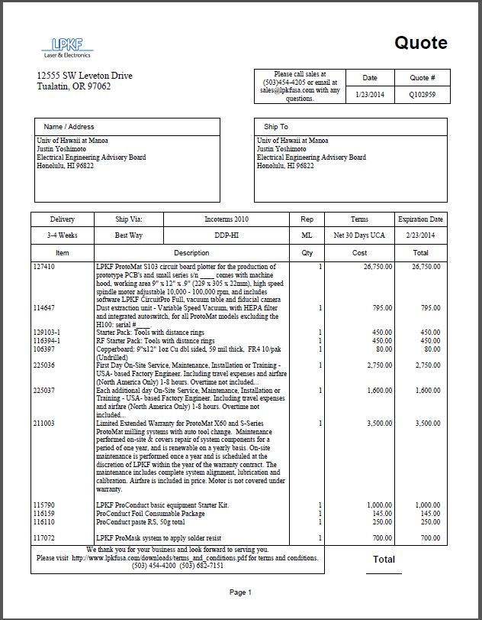

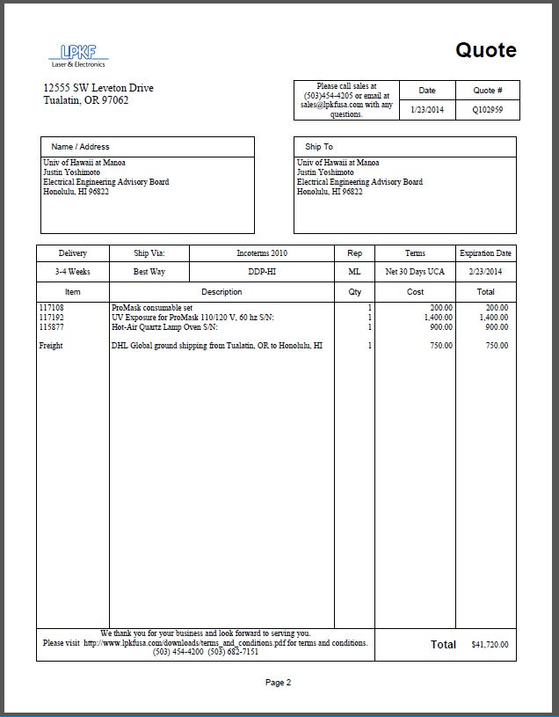

QCJ5 Quote

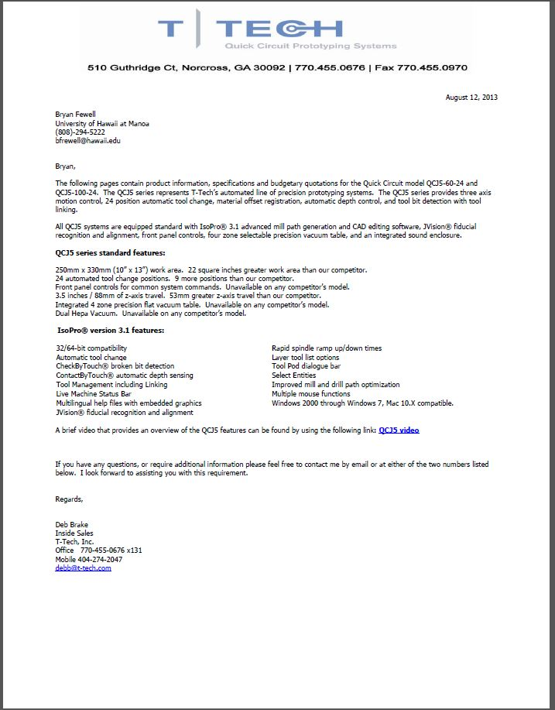

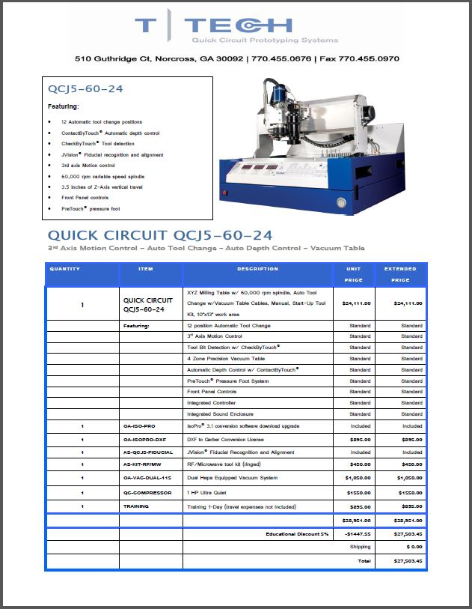

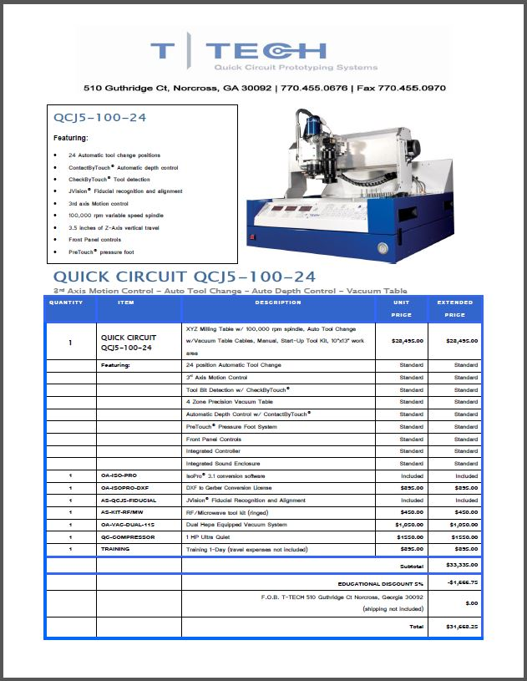

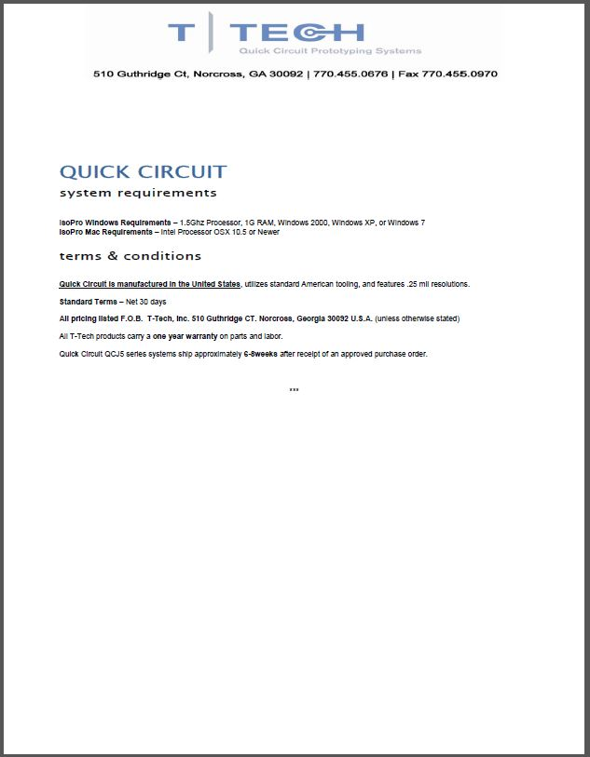

QCJ5 Specsheet

